

*Mark Villar*

*Information and Communications Technology*

*University of Sydney*

**Aim**

This study explores the socioeconomic circumstances and public health outcomes of Indigenous Australians, with particular emphasis on the quantitative analysis of large data sets. Our overarching aim is to provide better health and welfare services to Indigenous Australians, through the implementation of effective public policy. The Indigenous Health Check (MBS 715) data tool, provided by the Australian Institute of Health and Welfare (AIHW), is our primary source of raw data. Using the R and ArcGIS platforms, we hope to transform the existing SAS-based application to improve not just its data visualization features and mobile capabilities, but more importantly, the reliability of information obtained by government decision-makers in trying to ‘close the gap’ between Indigenous and non-Indigenous Australians.

**Data**

[The Health and Welfare of Australia’s Aboriginal and Torres Strait Islander People: An Overview (2011)](http://www.aihw.gov.au/indigenous-observatory/)

*A comprehensive 127-page report outlining the following:*

* Demographics of Aboriginal and Torres Strait Islander people
* Determinants of health and welfare: socioeconomic factors, housing, community capacity, behavioural factors, social and emotional wellbeing
* Health and functioning: community functioning, disability, health conditions
* Mortality and life expectancy
* Health across the life stages: mothers and babies, children, young people, older people
* Health care and other support services
* Health and welfare expenditure

[Source data as an Excel download (200 KB XLS)](http://www.aihw.gov.au/WorkArea/DownloadAsset.aspx?id=60129546847)

*Medicare Benefits Schedule (MBS) 715 is an annual health check for Aboriginal and Torres Strait Islander people of all ages.*

* Table 1: MBS item 715 by Medicare Local by quarter
* Table 2: MBS item 715 by Medicare Local by financial year

[Indigenous Health Check (MBS 715) data tool](http://analytics.aihw.gov.au/Viewer/VisualAnalyticsViewer_guest.jsp?reportPath=%2FAIHW%2FReleasedPublic%2FISHC%2FReports&reportName=Indigenous%20Health%20Checks&appSwitcherDisabled=true): *SAS interactive data portal*

* Tab 1: Quarters by map
* Tab 2: Financial years by map
* Tab 3: Comparison by quarters
* Tab 4: Comparison by financial years
* Tab 5: Trends by quarters
* Tab 6: Trends by financial years
* Tab 7: Overview by financial years
* Tab 8: Using this tool

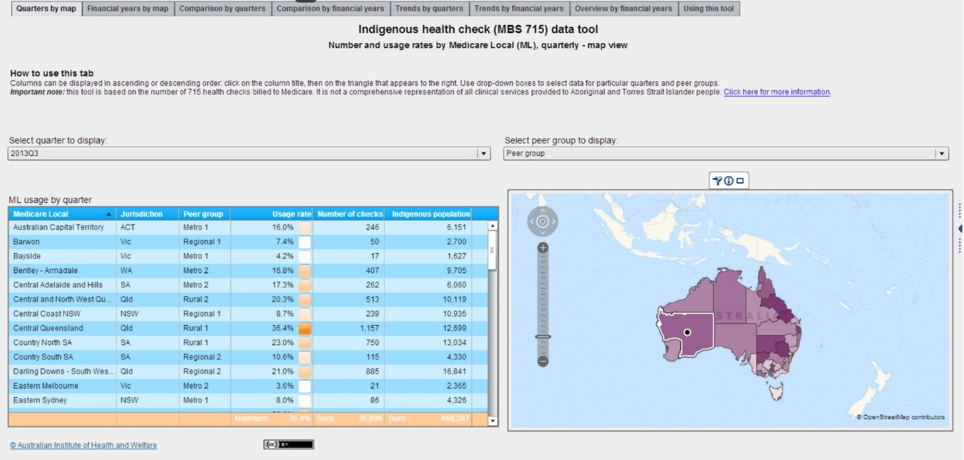

**Specifications**

* 61 Medicare Locals (MLs) – replaced *Divisions of General Practice* in 2011; MLs vary in terms of size, remoteness and population characteristics which makes comparisons between them difficult.
* 7 Peer groups – based on socioeconomic status and remoteness, including average distance to the closest large capital city and major hospital, making this type of stratification better for comparisons. The National Health Performance Authority allocated each ML to one of seven peer groups: Metro 1, Metro 2, Metro 3, Regional 1, Regional 2, Rural 1, Rural 2
* 8 Jurisdictions – ACT, NSW, NT, QLD, SA, TAS, VIC, WA
* ML Code – unique three-digit code for each of the 61 MLs.
* Usage rate (quarterly) = number of 715 health checks in the quarter divided by a quarter of the Indigenous population in the ML.
* Usage rate (financial year) = number of 715 health checks in the financial year divided by the Indigenous population in the ML.
* Number of checks = number of Indigenous health checks billed to Medicare as MBS item 715
* Indigenous population – data sourced from Population Health Information Development Unit at the University of Adelaide

**Exploratory Data Analysis**

*Table 1: MBS item 715 by ML by quarter*

* 488 observations of 7 variables
* Missing values (n=6) – Number of checks and Usage rates are not available for 6 observations where Indigenous populations are quite small (approx. 1300-2500 people). Three of the six missing values belong to Metro 1 groups in either NSW or VIC (ML107, ML108, ML206). Meanwhile, there are two missing quarterly observations for the same Metro 2 group in VIC (ML203) and another in a Regional 1 group, also in VIC (ML209).

*Table 2: MBS item 715 by ML by financial year*

* 122 observations of 7 variables
* No missing values in this table.

**Variables**

* *jurisd* – factor with 8 levels (nominal)
* *mlcode* – factor with 61 levels (nominal)
* *peergrp* – factor with 7 levels (nominal/ordinal)
* *quarter* – factor with 9 levels (ordinal)
* *year* – factor with 2 levels (ordinal)
* *nchecks* – number of checks (count)
* *usage* – usage rate (proportion)
* *popn* – population (count)

**SAS interactive data tool** – Indigenous Health Check (MBS 715)

The following Indigenous populations were obtained using the pull-down menus under Tabs 1 & 3 of the web-based data tool provided by the AIHW.

|  |  |
| --- | --- |
| **Peer group** | **Population** |
| Metro 1 | 24,798 |
| Metro 2 | 94,295 |
| Metro 3 | 63,020 |
| Regional 1 | 81,031 |
| Regional 2 | 172,791 |
| Rural 1 | 65,110 |
| Rural 2 | 167,242 |
| **Total** | **668,287** |

|  |  |
| --- | --- |
| **Jurisdiction** | **Population** |
| NSW | 204,533 |
| VIC | 50,999 |
| QLD | 188,503 |
| SA | 37,397 |
| WA | 87,693 |
| TAS | 24,165 |
| ACT | 6,151 |
| NT | 68,846 |
| **Total** | **668,287** |

|  |  |  |  |  |  |  |  |  |
| --- | --- | --- | --- | --- | --- | --- | --- | --- |
| **Jurisdiction** | **Metro 1** | **Metro 2** | **Metro 3** | **Regional 1** | **Regional 2** | **Rural 1** | **Rural 2** | **Total** |
| NSW | 13,586 | 3,652 | 29,980 | 62,901 | 86,382 | 8,033 | 0 | 204,534 |
| VIC | 5,061 | 4,325 | 11,034 | 5,207 | 21,663 | 3,709 | 0 | 50,999 |
| QLD | 0 | 46,293 | 12,920 | 7,051 | 25,267 | 40,334 | 56,638 | 188,503 |
| SA | 0 | 10,948 | 9,086 | 0 | 4,330 | 13,034 | 0 | 37,398 |
| WA | 0 | 29,077 | 0 | 5,872 | 10,986 | 0 | 41,758 | 87,693 |
| TAS | 0 | 0 | 0 | 0 | 24,165 | 0 | 0 | 24,165 |
| ACT | 6,151 | 0 | 0 | 0 | 0 | 0 | 0 | 6,151 |
| NT | 0 | 0 | 0 | 0 | 0 | 0 | 68,846 | 68,846 |
| **Total** | 24,798 | 94,295 | 63,020 | 81,031 | 172,793 | 65,110 | 167,242 | **668,289** |

We also collected data on the *maximum usage rates* and *total* *number of checks*for both quarterly and yearly intervals from Tabs 1 & 2. Further breakdowns that compare the data by *peer group* and *jurisdiction* were also obtained from Tabs 3 & 4. The tables below summarise the data we extracted from the interactive data tool.

*Tab 1: Quarters by map:* number of checks and usage rates by ML (map view)

* White geospatial map
* 9 quarters – 2011Q3 to 2013Q3

|  |  |  |
| --- | --- | --- |
| **Quarter** | **Max usage rate (%)** | **Total number of checks** |
| 2011Q3 | 38.6 | 21,990 |
| 2011Q4 | 32.0 | 21,721 |
| 2012Q1 | 35.0 | 25,245 |
| 2012Q2 | 36.3 | 27,564 |
| 2012Q3 | 36.2 | 28,920 |
| 2012Q4 | 45.5 | 28,085 |
| 2013Q1 | 32.9 | 30,309 |
| 2013Q2 | 39.0 | 34,813 |
| 2013Q3 | 36.4 | 35,896 |

*Tab 2: Financial years by map:* number of checks and usage rates by ML (map view)

* Greyscale geospatial map
* 2 financial years – 2011-2012 and 2012-2013

|  |  |  |
| --- | --- | --- |
| **Financial year** | **Max usage rate (%)** | **Total number of checks** |
| 2011-12 | 32.3 | 96,520 |
| 2012-13 | 34.1 | 122,127 |

*Tab 3: Comparison by quarters:* number of checks and usage rates by ML (bar chart view)

* User selects Jurisdiction, Peer group and Quarter to display Usage rate information as a *static bar chart*

|  |  |  |  |  |  |  |  |  |  |  |  |  |  |  |
| --- | --- | --- | --- | --- | --- | --- | --- | --- | --- | --- | --- | --- | --- | --- |
| **Quarter** | **Metro 1** | | **Metro 2** | | **Metro 3** | | **Regional 1** | | **Regional 2** | | **Rural 1** | | **Rural 2** | |
| **Max usage rate** | **Number of checks** | **Max usage rate** | **Number of checks** | **Max usage rate** | **Number of checks** | **Max usage rate** | **Number of checks** | **Max usage rate** | **Number of checks** | **Max usage rate** | **Number of checks** | **Max usage rate** | **Number of checks** |
| 2011Q3 | 8.3 | 321 | 18.0 | 2,523 | 18.8 | 1,458 | 9.5 | 1,297 | 24.6 | 5,282 | 38.6 | 3,608 | 21.4 | 7,501 |
| 2011Q4 | 11.6 | 467 | 15.8 | 2,403 | 14.8 | 1,229 | 13.1 | 1,421 | 32.0 | 5,739 | 31.0 | 3,649 | 19.1 | 6,813 |
| 2012Q1 | 10.2 | 461 | 22.6 | 3,144 | 19.0 | 1,448 | 14.2 | 1,629 | 35.0 | 6,202 | 32.4 | 4,383 | 20.2 | 7,978 |
| 2012Q2 | 13.0 | 483 | 21.6 | 3,205 | 16.0 | 1,411 | 14.4 | 2,115 | 31.3 | 6,719 | 36.3 | 4,712 | 25.9 | 8,919 |
| 2012Q3 | 14.2 | 520 | 22.4 | 3,766 | 20.2 | 1,717 | 16.6 | 2,217 | 30.5 | 6,873 | 36.2 | 4,963 | 27.2 | 8,864 |
| 2012Q4 | 18.5 | 563 | 22.7 | 3,895 | 14.1 | 1,431 | 16.7 | 2,064 | 45.5 | 6,588 | 32.8 | 4,276 | 24.8 | 9,268 |
| 2013Q1 | 14.6 | 583 | 29.5 | 4,724 | 16.3 | 1,489 | 15.9 | 2,081 | 29.6 | 7,124 | 32.9 | 4,382 | 28.6 | 9,926 |
| 2013Q2 | 17.6 | 594 | 35.1 | 5,166 | 19.3 | 1,878 | 17.1 | 2,467 | 35.0 | 8,453 | 39.0 | 5,225 | 34.4 | 11,030 |
| 2013Q3 | 16.0 | 634 | 34.2 | 5,416 | 31.7 | 2,417 | 17.8 | 2,828 | 35.7 | 8,691 | 36.4 | 5,314 | 29.0 | 10,596 |
| **Total** |  | **4,626** |  | **34,242** |  | **14,478** |  | **18,119** |  | **61,671** |  | **40,512** |  | **80,895** |
| Popn | 24,798 | 94,295 | 63,020 | 81,031 | 172,791 | 65,110 | 167,242 |

|  |  |  |  |  |  |  |  |  |  |  |  |  |  |  |  |  |
| --- | --- | --- | --- | --- | --- | --- | --- | --- | --- | --- | --- | --- | --- | --- | --- | --- |
| **Quarter** | **ACT** | | **NSW** | | **NT** | | **QLD** | | **SA** | | **TAS** | | **VIC** | | **WA** | |
| **Max usage rate** | **Number of checks** | **Max usage rate** | **Number of checks** | **Max usage rate** | **Number of checks** | **Max usage rate** | **Number of checks** | **Max usage rate** | **Number of checks** | **Max usage rate** | **Number of checks** | **Max usage rate** | **Number of checks** | **Max usage rate** | **Number of checks** |
| 2011Q3 | 3.4 | 53 | 38.6 | 6,289 | 19.0 | 3,268 | 23.5 | 8,431 | 9.9 | 663 | 2.4 | 144 | 18.7 | 922 | 16.1 | 2,220 |
| 2011Q4 | 11.6 | 179 | 31.0 | 6,391 | 19.1 | 3,290 | 27.1 | 7,843 | 9.1 | 598 | 2.6 | 160 | 32.0 | 1,153 | 13.5 | 2,107 |
| 2012Q1 | 7.3 | 113 | 28.2 | 6,966 | 20.0 | 3,442 | 32.4 | 9,557 | 16.1 | 863 | 3.6 | 220 | 35.0 | 1,209 | 19.5 | 2,875 |
| 2012Q2 | 11.2 | 172 | 31.6 | 7,769 | 21.5 | 3,701 | 36.3 | 10,824 | 15.9 | 874 | 4.2 | 252 | 31.3 | 1,237 | 18.4 | 2,735 |
| 2012Q3 | 14.2 | 218 | 31.2 | 8,129 | 22.3 | 3,840 | 36.2 | 11,275 | 17.4 | 965 | 4.1 | 249 | 27.1 | 1,189 | 21.3 | 3,055 |
| 2012Q4 | 18.5 | 284 | 32.8 | 7,601 | 23.3 | 4,010 | 30.9 | 9,833 | 16.0 | 931 | 3.8 | 227 | 45.5 | 1,476 | 24.8 | 3,723 |
| 2013Q1 | 11.8 | 181 | 26.2 | 7,823 | 25.6 | 4,407 | 32.9 | 11,363 | 12.7 | 842 | 5.3 | 322 | 29.6 | 1,433 | 28.6 | 3,938 |
| 2013Q2 | 12.0 | 185 | 39.0 | 9,403 | 23.8 | 4,104 | 36.1 | 13,165 | 17.6 | 1,142 | 5.9 | 358 | 34.1 | 1,655 | 35.1 | 4,801 |
| 2013Q3 | 16.0 | 246 | 35.7 | 9,807 | 25.3 | 4,351 | 36.4 | 13,357 | 23.0 | 1,372 | 5.6 | 340 | 33.4 | 1,796 | 30.5 | 4,627 |
| **Total** |  | **1,631** |  | **70,178** |  | **34,413** |  | **95,648** |  | **8,250** |  | **2,272** |  | **12,070** |  | **30,081** |
| Popn | 6,151 | 204,533 | 68,846 | 188,503 | 37,397 | 24,165 | 50,999 | 87,693 |

*Tab 4: Comparison by financial years:* number of checks and usage rates by ML (bar chart view)

* User selects Jurisdiction, Peer group and Year to display Usage rate information as a *static bar chart*

|  |  |  |  |  |  |  |  |  |  |  |  |  |  |  |
| --- | --- | --- | --- | --- | --- | --- | --- | --- | --- | --- | --- | --- | --- | --- |
| **Year** | **Metro 1** | | **Metro 2** | | **Metro 3** | | **Regional 1** | | **Regional 2** | | **Rural 1** | | **Rural 2** | |
| **Max usage rate** | **Number of checks** | **Max usage rate** | **Number of checks** | **Max usage rate** | **Number of checks** | **Max usage rate** | **Number of checks** | **Max usage rate** | **Number of checks** | **Max usage rate** | **Number of checks** | **Max usage rate** | **Number of checks** |
| 2011-12 | 9.9 | 1,732 | 17.8 | 11,275 | 17.1 | 5,546 | 12.7 | 6,462 | 28.0 | 23,942 | 32.3 | 16,352 | 21.0 | 31,211 |
| 2012-13 | 14.1 | 2,260 | 25.3 | 17,551 | 17.5 | 6,515 | 16.6 | 8,829 | 34.1 | 29,038 | 33.9 | 18,846 | 29.9 | 39,088 |
| **Total** |  | **3,992** |  | **28,826** |  | **12,061** |  | **15,291** |  | **52,980** |  | **35,198** |  | **70,299** |
| Popn | 24,798 | 94,295 | 63,020 | 81,031 | 172,791 | 65,110 | 167,242 |

*Tab 5: Trends by quarters:* usage rates by ML (trend line view)

* User selects ML, Jurisdiction, Peer group and Quarter(s).
* Tick boxes allow multiple selection by Quarters.
* **Note:** Quarterly trend lines can show considerable variations in usage. Annual reports give less variable information about usage. For this reason, we do not analyze this tab in further detail. Trends should also be interpreted with caution, particularly where they relate to small populations.

*Tab 6: Trends by financial years:* usage rates by ML (bar chart view)

* User selects ML, Jurisdiction, Peer group and Financial Year(s).

*Tab 7: Overview by financial years:* usage rates and population by ML (tree map view)

* User selects Jurisdiction, Peer group and Financial Year(s).

*Tab 8: Using this tool:* tips on using the tool and explanation of the terminology

**Design**

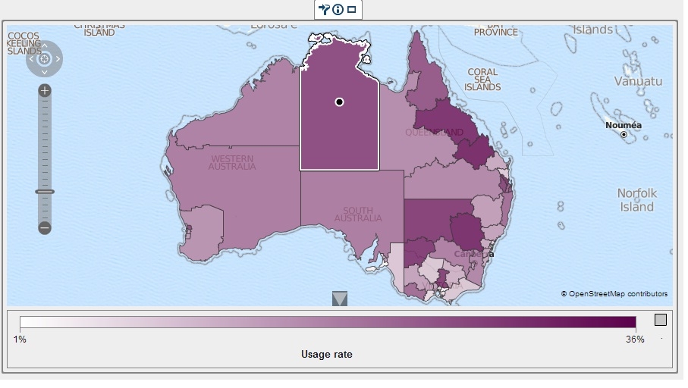Interactive map below is totally underwhelming.

User interface with multiple tabs and pull-down menus – information is “hidden” and navigation is clunky.

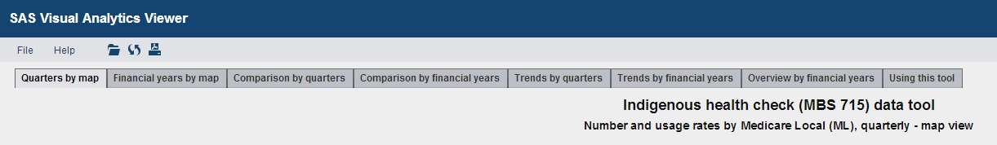

Colour scheme – poor text contrast makes Summary Statistics at the bottom of tables difficult to read clearly.

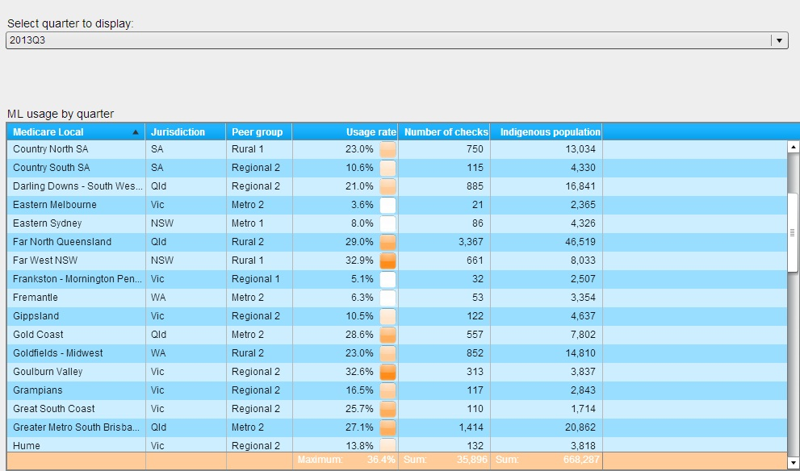

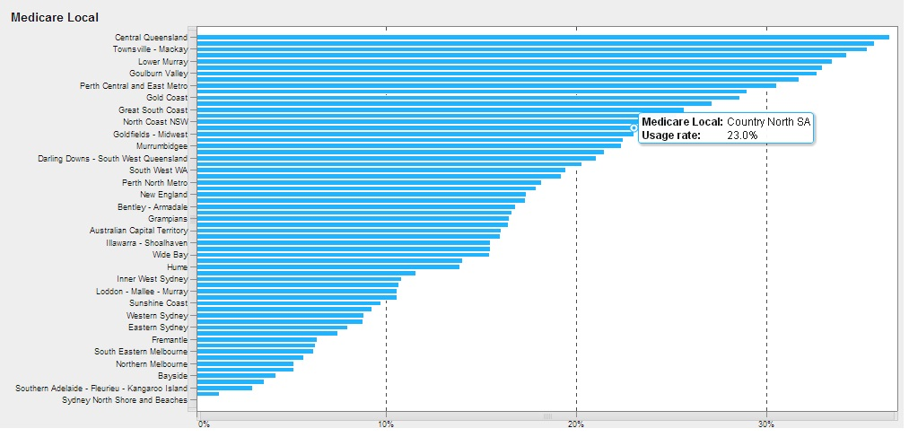Static monochromatic charts – bar charts, trendlines, tree map (boring!!)

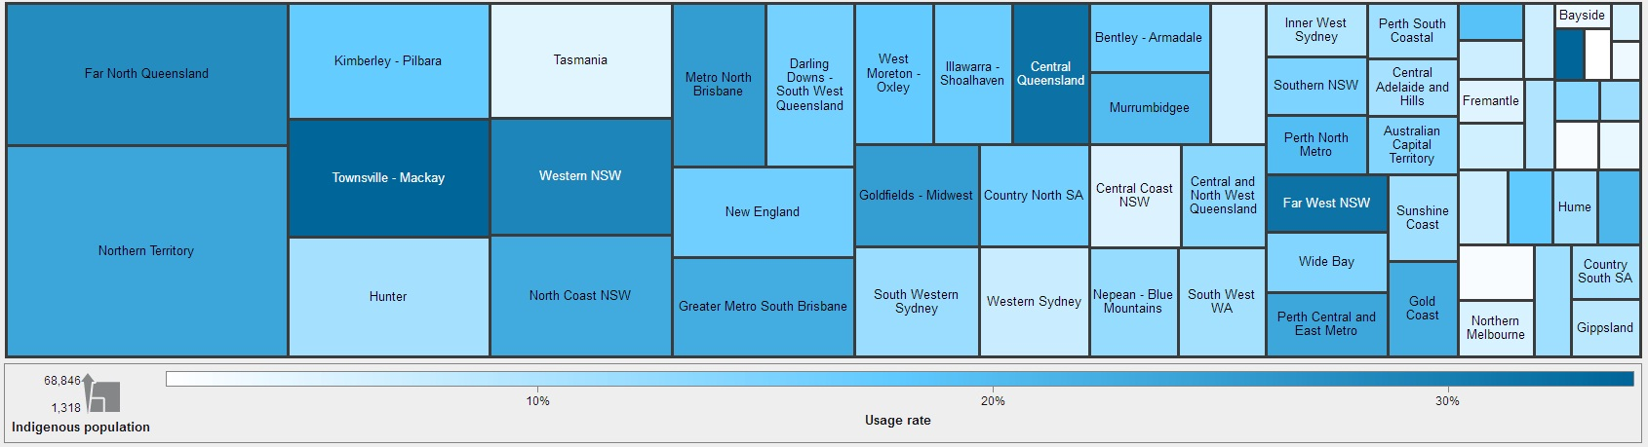

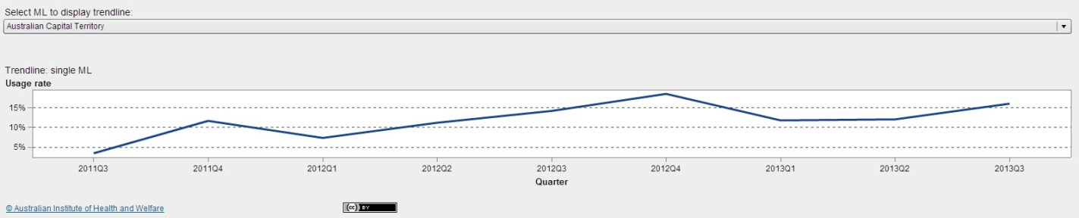**Hypothesis Testing**

[Insert hypotheses here]

**Methods**

*Geographical data tools:*

<http://www.r-bloggers.com/starting-analysis-and-visualisation-of-spatial-data-with-r/>

<http://www.r-bloggers.com/3d-mapping-in-r/>

<http://www.esri.com/software/arcgis/arcgisonline>

<https://sydneyuni.maps.arcgis.com>

*Statistical techniques:*

* Analysis of variance (ANOVA)
* Contingency tables (chi-squared tests)
* Estimation and prediction (regression)
* Data mining and machine learning
* Factor and cluster analysis

**Software**

RStudio

Statwing

ArcGIS

CartoDB

GitHub

ShareLaTeX

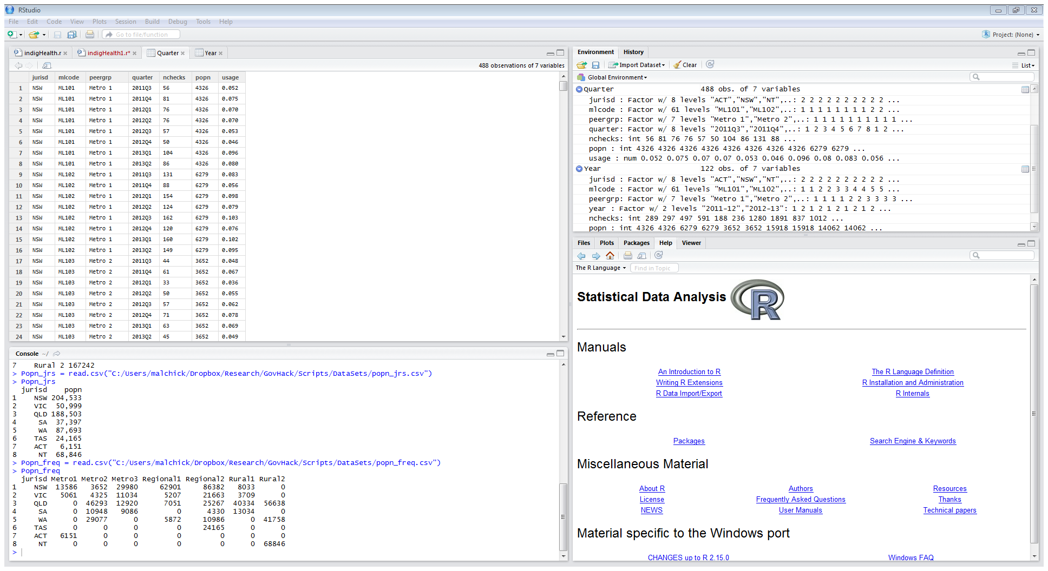

**The R Project for Statistical Computing**

[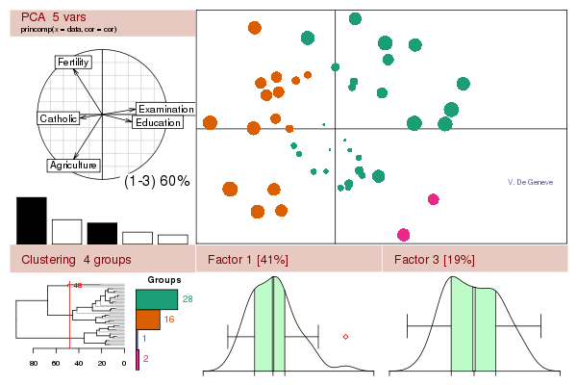](http://www.r-project.org/misc/acpclust.R)

|  |
| --- |
| **Getting Started:**   * R is a free software environment for statistical computing and graphics. It compiles and runs on a wide variety of UNIX platforms, Windows and MacOS. To [**download R**](http://cran.r-project.org/mirrors.html), please choose your preferred [CRAN mirror](http://cran.r-project.org/mirrors.html). * If you have questions about R like how to download and install the software, or what the license terms are, please read our [answers to frequently asked questions](http://cran.r-project.org/faqs.html) before you send an email. |
| **News:**   * [**R 3.1.1 (Sock it to Me) prerelease versions**](http://cran.r-project.org/src/base-prerelease) will appear starting June 30. Final release is scheduled for July 10, 2014. * **R version 3.1.0** (Spring Dance) has been released on 2014-04-10. * **R version 3.0.3** (Warm Puppy) has been released on 2014-03-06. * [**The R Journal Vol.5/2**](http://journal.r-project.org/) is available. * [**useR! 2013**](http://www.r-project.org/useR-2013), took place at the University of Castilla-La Mancha, Albacete, Spain, July 10-12 2013. * **R version 2.15.3** (Security Blanket) has been released on 2013-03-01. |

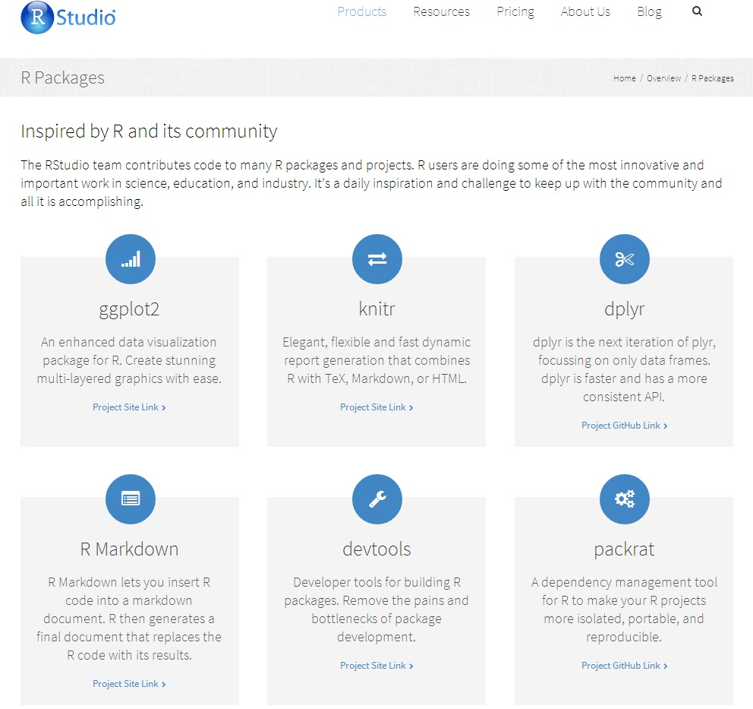

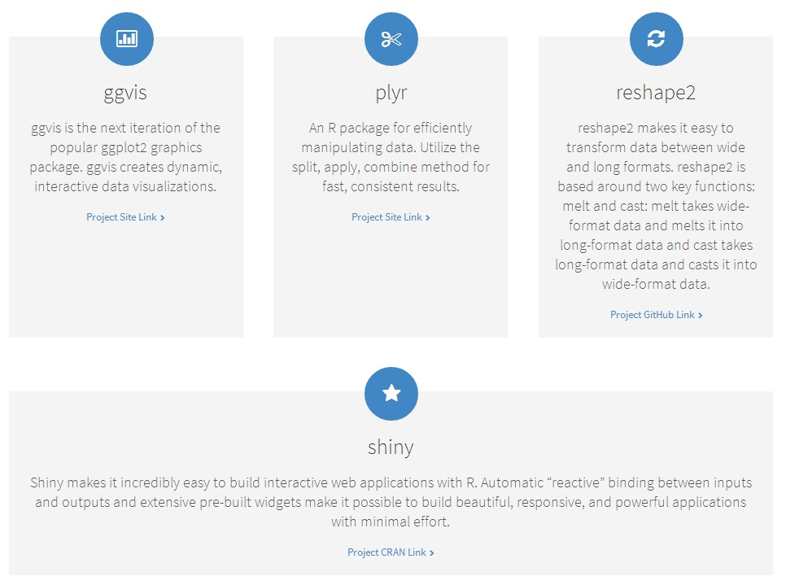

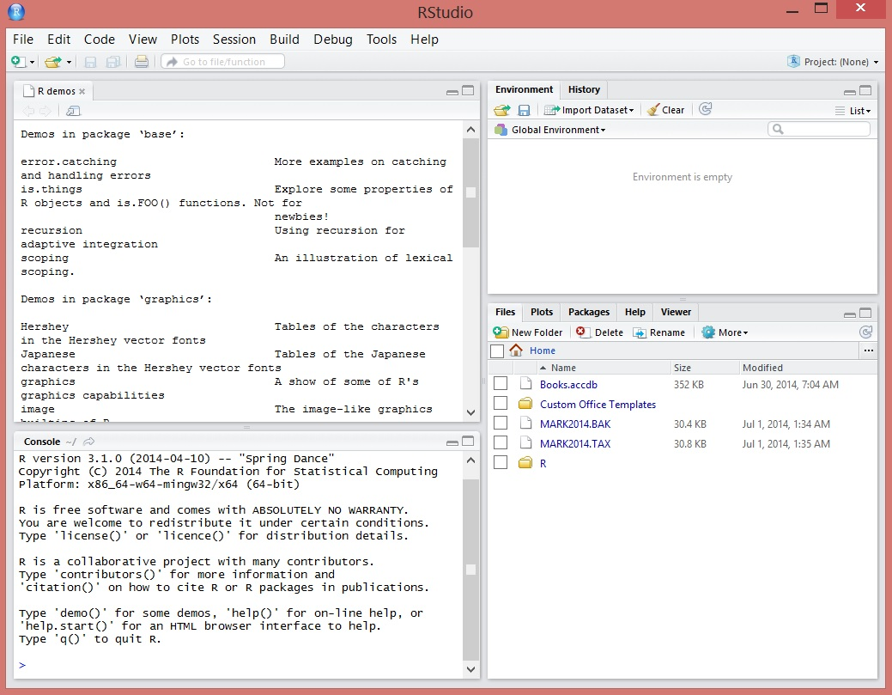

**Learning RStudio for R Statistical Computing**

van der Loo, Mark P.J.; de Jonge, Edwin

A practical tutorial covering how to leverage RStudio functionality to effectively perform R Development, analysis, and reporting with RStudio. The book is aimed at R developers and analysts who wish to do R statistical development while taking advantage of RStudio functionality to ease their development efforts. Familiarity with R is assumed. Those who want to get started with R development using RStudio will also find the book useful. Even if you already use R but want to create reproducible statistical analysis projects or extend R with self-written packages, this book shows how to quickly achieve this using RStudio.

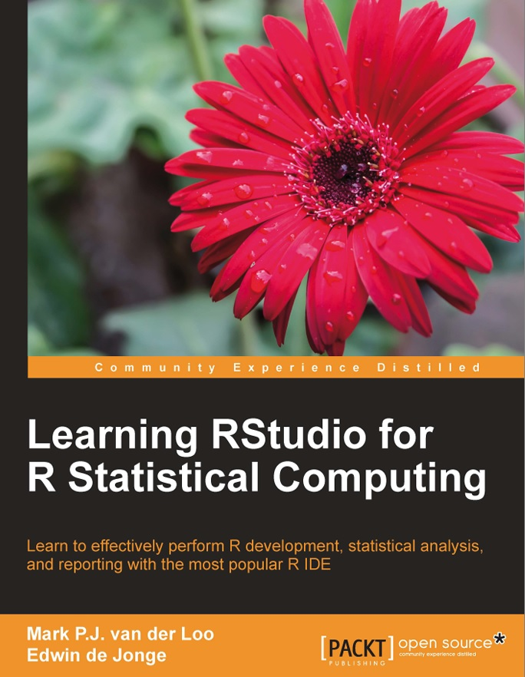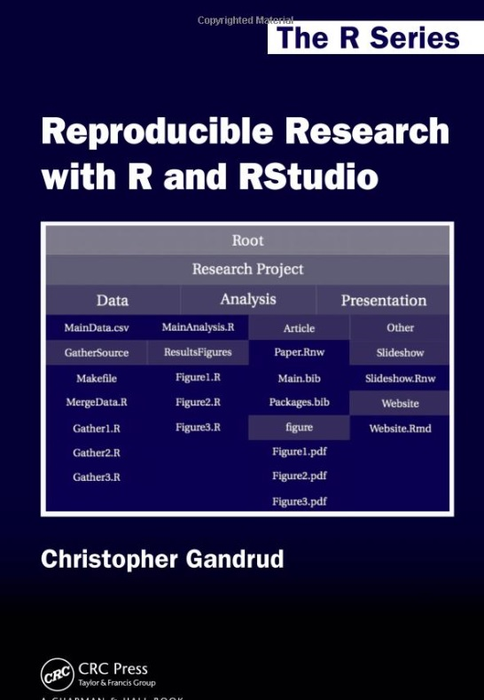

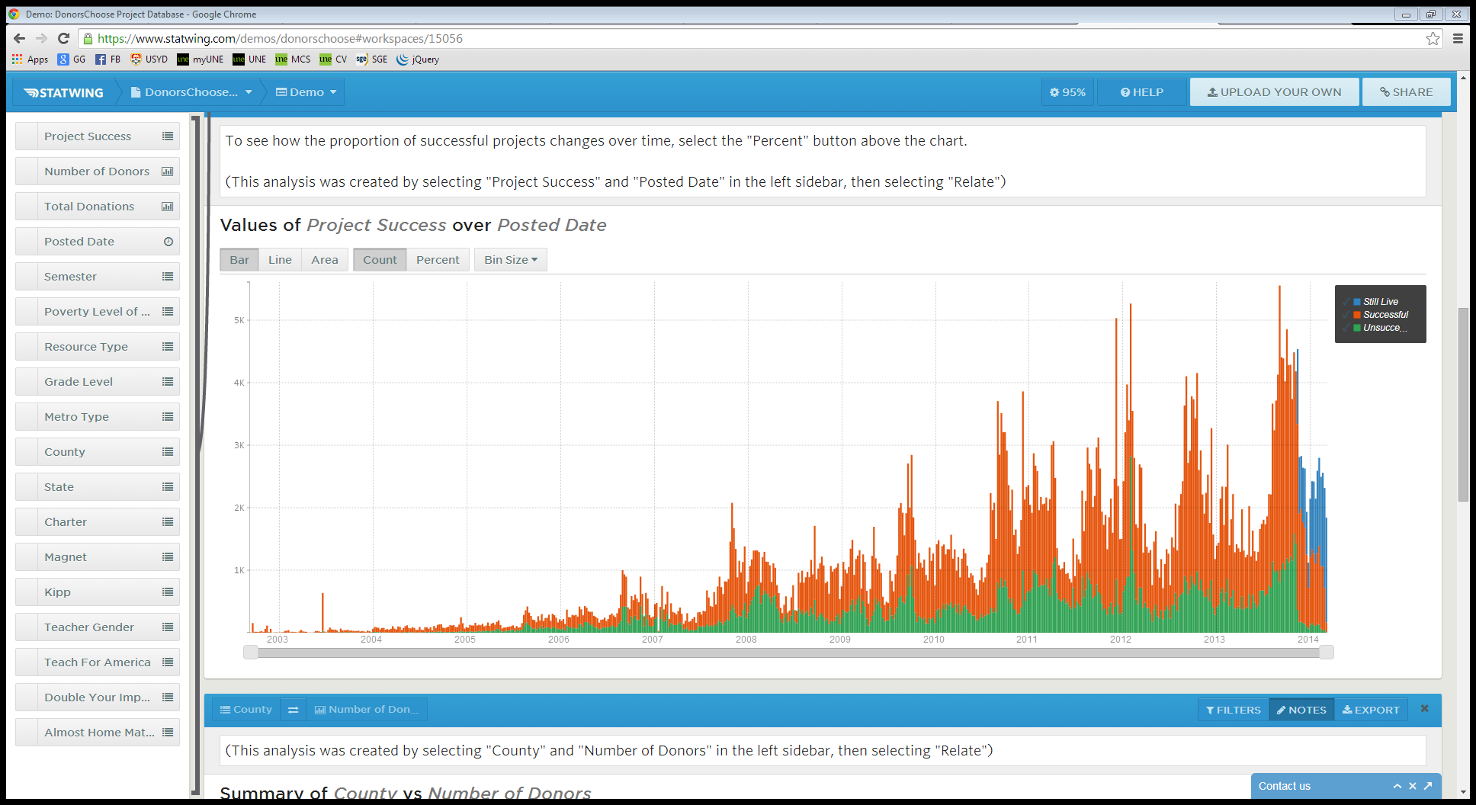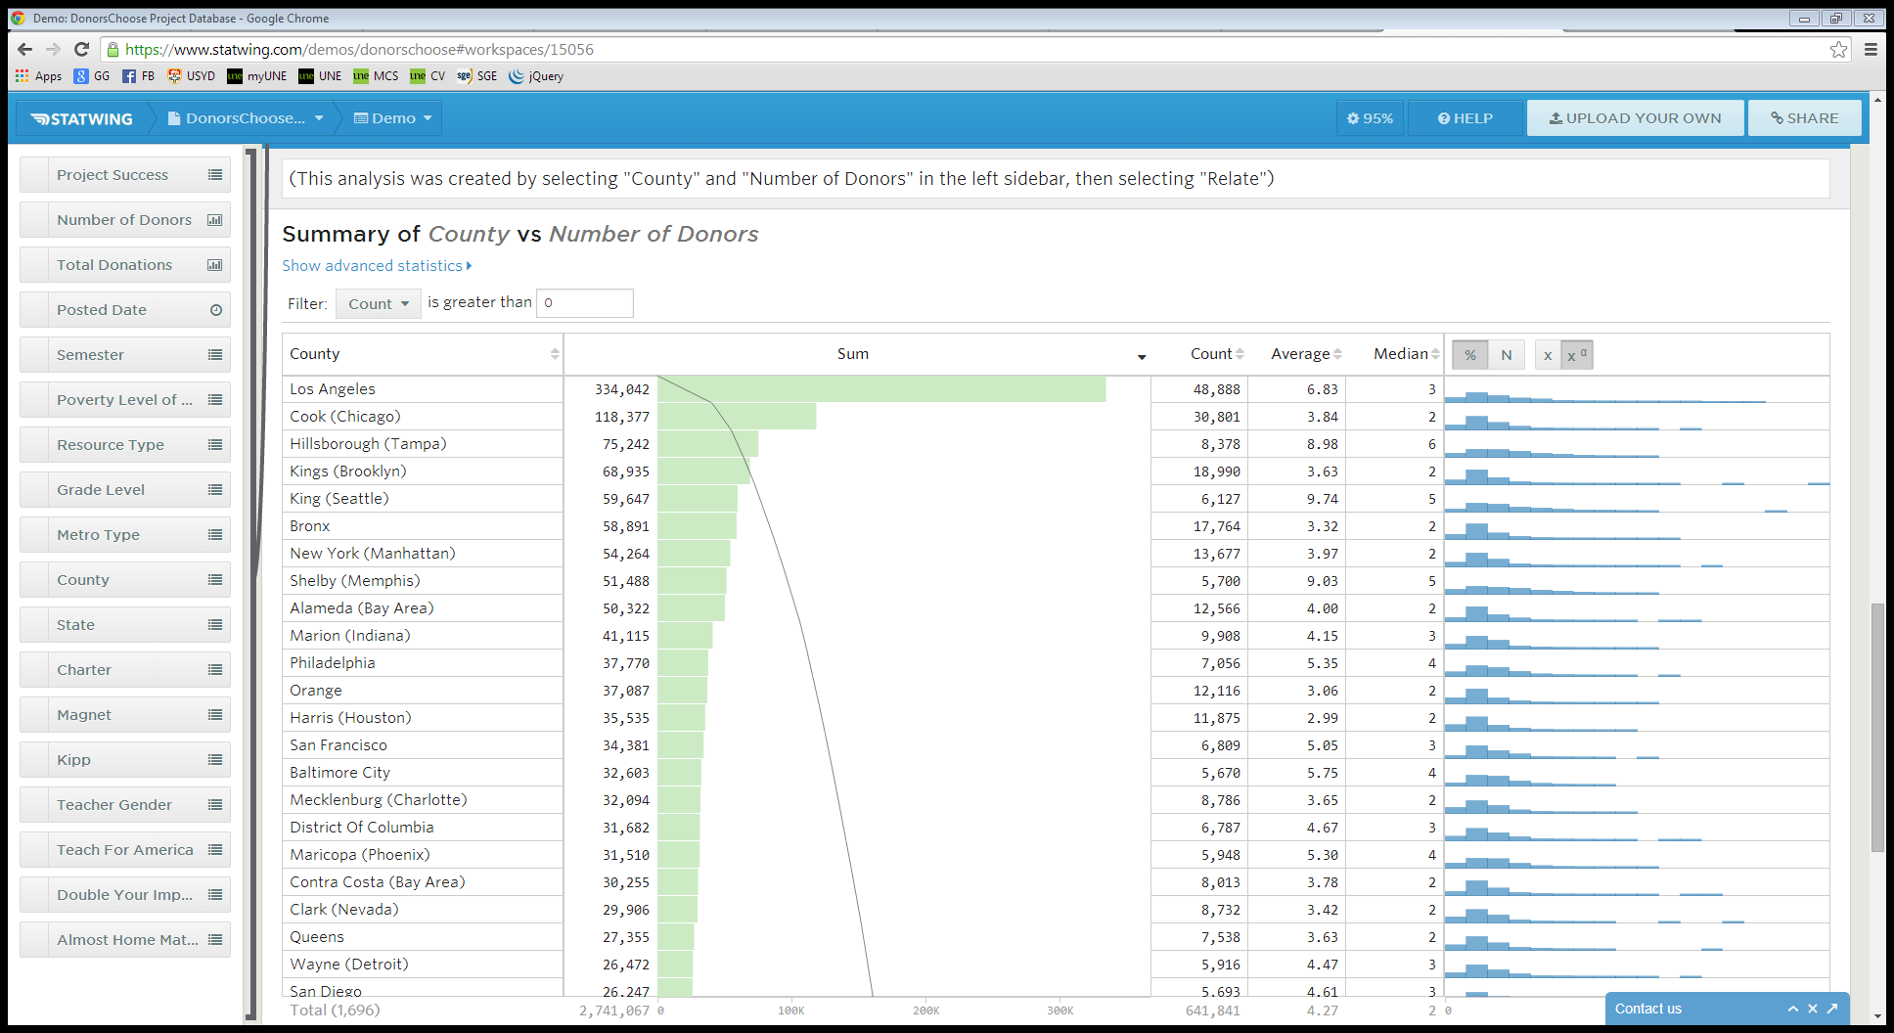

Top of Form

# ArcGIS Online

The Mapping Platform for Your Organization

# Map Your World Your Way

ArcGIS Online gives you everything you need to create interactive web maps and apps that you can share with anyone. With ready-to-use content, apps, and templates you can be productive right away. And no matter what you use—desktops, browsers, smartphones, or tablets—you always have access to your content.

[Watch the Video: What is ArcGIS?](http://video.arcgis.com/iframe/916/000000/width/960/0/00:00:00)

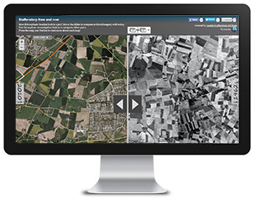

## Make Maps Your Way

Combine your data with data from Esri and other contributors to create maps for the work you do. Ready-to-use basemaps, tools, templates, and datasets make it easy to design and publish maps online.

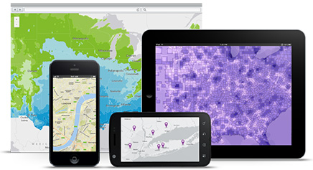

## Explore a World of Content

Browse the world’s most extensive online geographic resource and discover maps and data about thousands of topics. Combine content any way you want and see it on a map.

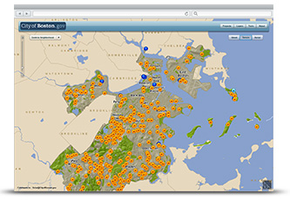

## Get Location-Based Insights

Whether you are a scientist, decision-maker, or just curious, you will see location in a new way. By analyzing relationships and patterns you can better understand problems and locate opportunities.

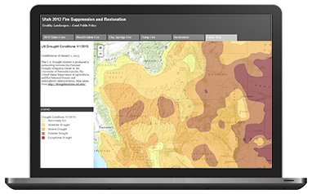

## Connect with People Using GIS

Everyone in your organization can share the latest maps, data, and ideas on a single platform. Create project groups, customize work tools, and build your own web apps to connect people through GIS.

